**Research document**

Concept statement: :”A tool to assist children who are struggling with their learning”

Expand each point fully

**Competitors** - **[Zineddine Daif]**

The application store is vast, it increases in size and apps constantly and inevitably different ideas and concepts will inspire others to create similar applications. The bar is raised each and every day and during our current present the chances of creating a successful application may seem just as high as winning the lottery. There are hundreds of tutoring applications which all provide different features and ultimately every single one of them is building upon their foundation to create the perfect tutoring application.

The first competitor I looked into which provided an online tutoring service went by the name of **Cheg Tutors**. Cheg Tutors provides homework help and online tutoring. It allows any student to get that ever so needed one-on-one tuition from expert tutors from top colleges around the country. Unlike TutorUNI the tutoring is all done online on either live video chat or through a messaging service. TutorUNI provides a more practical experience and as said by [MICHAEL GODSEY](https://www.theatlantic.com/author/michael-godsey/) students are more engaged and focused when an actual tutor is present as opposed to staring at a bottomless screen for hours on end. The application provides tuition for any subject and specifies a target audience of anyone in need of tuition regardless of age.

**Cheg Tutors** have an interesting revenue model where prices start from just .50/minute. The company offers each new customer 30 minutes of free tutoring so that each student know what kind of experience they are letting themselves in for before they spend their money. Each tutor is paid 20. Per hour as a minimum and the 50. Is applied to the exact number of minutes accumulated during a given week. This company is also based in America and are not available in the UK.

(could not find information on how the business made money)

**SAT up** is a tutoring application which gives students tuition without the use of an actual tutor. SAT up is a tuition application which specialises in SATs which means the audience they are targeting are aged between 6 and 11 y/o. The application provides a number of really interesting features including In app games to help with studying, personalised workouts and more. An interesting feature the application provides is the personalised workouts which become more and more suited to the student as they progress with the workouts each day. The app also provides feedback from tutors which will take at maximum 24 hours to reply.

**SAT up** charges a monthly fee of 4.99 which allows unlimited use of all of the features they have to offer. The application asks the user for a debit card which will get debited each month. The price is very affordable and considering the features very good value for money also.

**Tutree** is an application I found online which is very similar to our concept TutorUNI. Tutree provides help on homework, revision help with exams, general tuition and more. The application says they can provide you a tutor within minutes once requested and give the students the option to compare the different tutors available in the area they are within. The application also has a GPS based service and provides a map with areas where tutors are available. The application has a built-in rating system so that students can see ratings of each tutor available to them. Both student and tutor have the option to rate each other out of 5 stars and also have the option to leave a review. Payments are made through the application once a debit card has been added to the account.

Each tutor has a fee which is shown on their profile, however this fee is not fixed and can be discussed in the messaging service that the application provides. Most fees range from 25. and up. The application takes a cut of each transaction made between the client and the Tutor.

(I could not find this percentage)

//Not finished

1. Who are our competitors?
2. What products and services do they currently have?
3. Who are their target audience?
4. Who are their competitors?
5. How well are they doing?

What is their revenue model? **[]**

1. What legal safeguards do they have in place?
2. Are they responsible for the target market using their servth aice including, healnd safety (What are the health and safety regulations)?
3. What are the licences required?
4. Comparison between our services?

Indirect competitors and direct

10. What are the costs and how to maintain it?

**Reviews - [Benji]**

**Tutor Hunt**

The first competitor looked at is Tutor Hunt. On the UK Trustpilot website (<https://uk.trustpilot.com/review/www.tutorhunt.com>), there are 840 reviews, and from these 88% of them give Tutor Hunt the top tier rating, which is excellent. Some of these reviews are as follows:

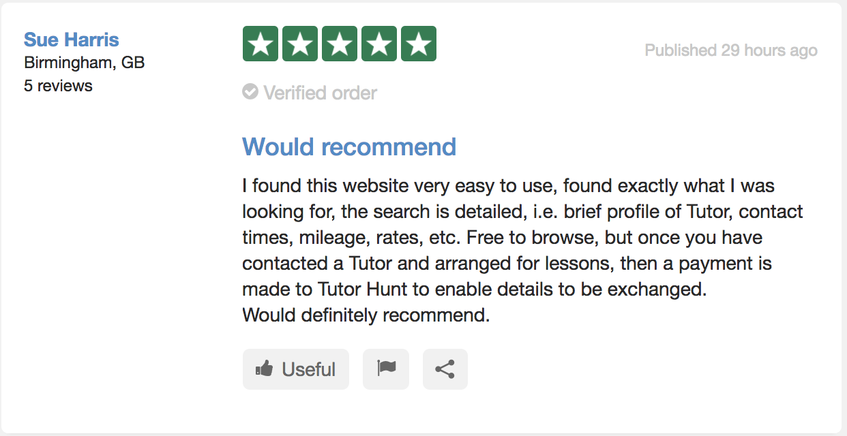

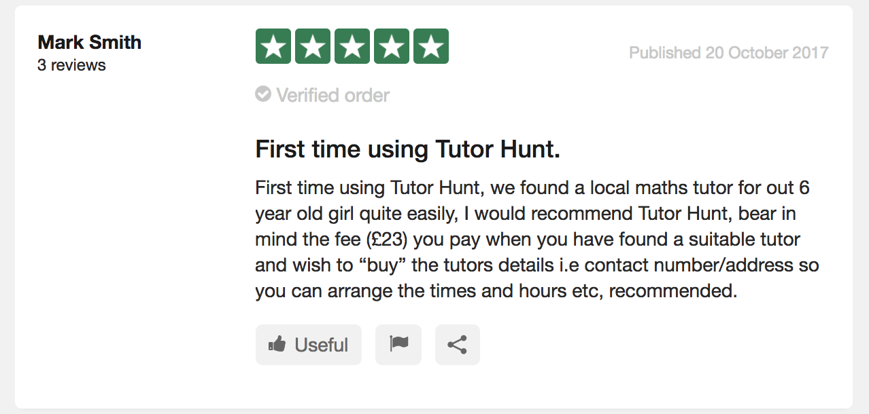

From the 88% Excelend reviews, users emphasise the simplicity of the site, and how it is clear to use, and the use of short descriptions for the tutors allows those seeking tutoring and quick way to sort through the results and find a suitable match.

Although most have positive reviews, 1% of the users have only rated 1* rating, some of which can be seen below:

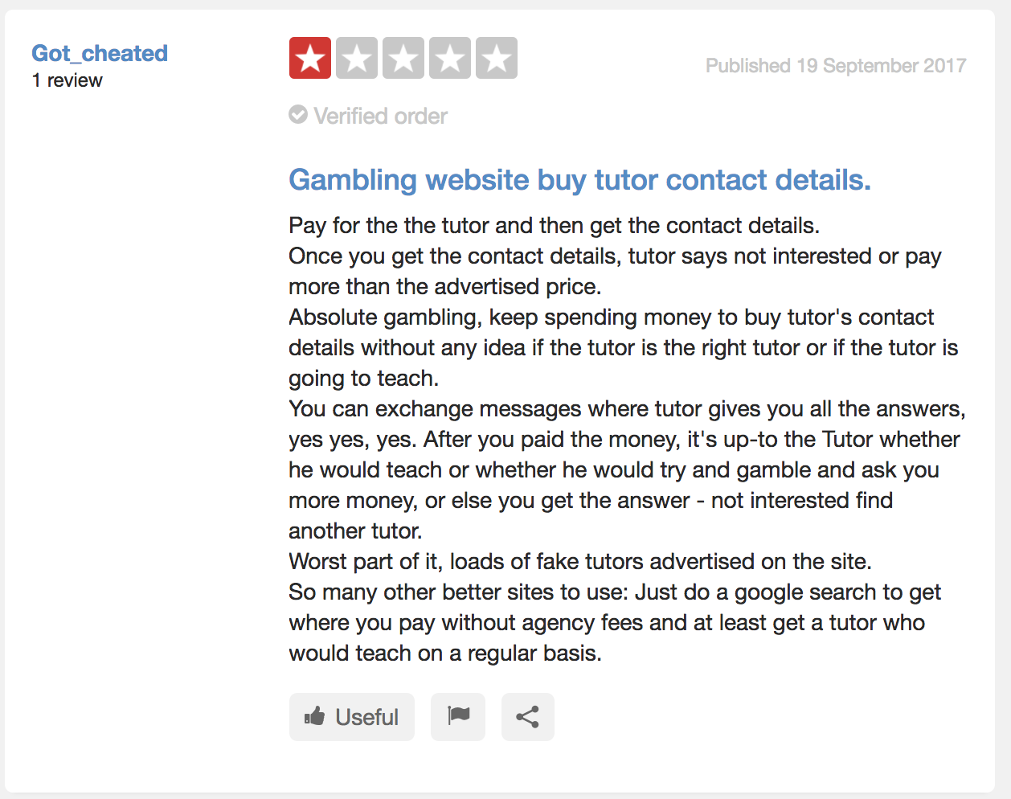

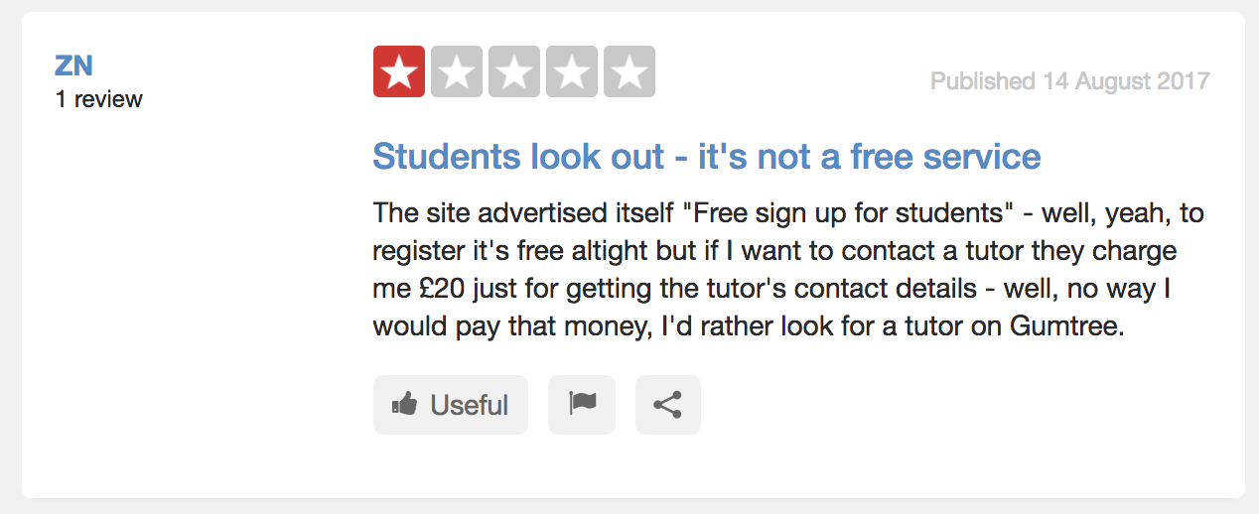

Although the minority, these reviews highlight some issues users have faced, especially highlighting the fact that, although they may have paid to get a tutors contact details, the tutor may then not chose to teach them, effectively meaning the user has ‘wasted’ their money. Other issues highlighted are the the uncertainty of how the site is used (how people pay for the service) alongside some people paying to then have unreliable tutors.

Other sites such as Site Jabber (<https://www.sitejabber.com/reviews/www.tutorhunt.com>) have nearly 30% of their reviewds 1*, with most reviewers emphasising that the high costs put them off the service.

Asses competitors using research from forums, reviewing sites or even primary research such as recording or videos.

So ask the questions from **COMPETITORS** to users

Ask users whether they like the revenue models and what they could improve on competitors

**Legal - (Coreen)**

*Legal implications when working with children?*

Whilst look at a website called TutorCruncher which is a website that helps small businesses take care of their invoicing etc, a Start-up consultant has given a few pointers on the legal aspects of starting a tutoring company.

[<https://tutorcruncher.com/legal-implications-when-starting-a-tutoring-business/>] [Accessed 26 October 2017]

Disclosure and Barring Service (DBS) Checks:

All jobs in the UK that involve working with children require a DBS check to be carried out this is a detailed police check to ensure that the person that is being checked does not have any restrictions on their ability to work with children. Every potential tutor also needs to have their identity verified with the following:

* Passport;
* Two references from employers;
* Proof of being eligible to work in the UK;
* Educational qualifications

Confidentiality Agreement

It is suggested by TutorCruncher that a confidentiality agreement should be signed by all tutors in order to protect the interests of the client(s). This could include, but not limited to, high net worth clients (the confidentiality agreement would ensure that any confidential information of the client will be protected) as Tutors may come across confidential information within the client’s home whilst tutoring the child.

Terms of engagement

There should be terms of engagement in place so that it is clear on what terms the tutor will be employed. For example, will the tutor be self-employed? If they are to be employed by you will they be paid weekly, fortnightly, monthly? Will the tutor be responsible for paying tax, will they be entitled to holiday pay or sick pay? If they are to be employed by you what protection will they be entitled to. Will the tutor be working with your exclusively or will they have the freedom to work with other agencies (will this cause a conflict of interest if they are working with other agencies). The terms of engagement should be signed on commencement or just before employed starts.

Social Media policy and advertising

There needs to be some consideration taken when advertising the tutoring business as there may be legal implications of how you advertise for example giving out flyers outside of a school playground to parents. There are rules and regulations in place on how you should advertise and not to have misleading advertisements and direct marketing.

(Advertising Standards Authority)

Data Protection Act

What are the rules around Data Protection Act

Syllabus

How are we going to improvise on the risks involved?

How would we acquire certain licences (including costs)?

How much is a DBS Check?

How much does it cost to right a disclosure agreement/confidentiality agreement?

Advertising Standards Authority

Who are responsible for the risks (if there were any to happen)?

Dispute resolution

**How do our competitors display their legal information - [Please add your name]**

How are we going to portray the legal terms to the users of the app?

Do our competitors have the legal terms in a transparent way?

Data protection, can we get data from the university for their students involved?

Can we get departments or tutors to verify the student's’ account physically (By visiting the tutors)

**Licence - Aaron**

What licences are required?

- ***Apple Developer Program Agreement***

The Developer Program Agreement is Apple’s fee-based subscription that allows members to publish apps for devices based on the business’s mobile operating system to the app store.

Members must be a registered developer/Apple customer in order to submit their application to Apple for approval for them to make the app available via the iTunes app store. If members plan on charging for the app, Apple keeps 30% of the chosen sales price for the app to cover housing cost, DRM (Digital Rights Management) protection, and credit card etc. This agreement costs developers £99 a year which is renewable once expired.

Included in this program, Apples have incorporated the intellectual property license which allows for distribution of the app to end users, including hosting and displaying the app, making copies thereof and allowing end user to download the content itself. This would ultimately hold the right type of protection to stop people stealing or copying; the name of the app, our inventions, the design or look of the app etc.

- ***Google Play Licensing***

Google Play Licensing is a network-based service that lets an application query a trusted Google Play licensing server to determine whether the application is licensed to the current device user. The licensing service is based on the capability of the Google Play licensing server to determine whether a given user is licensed to use a given application. Google Play considers a user to be licensed if the user is a recorded purchaser of the application.

Similarly, to Apple, Google Play takes also 30% from in-app purchases income however, their pricing differs as a one-time fee of £25 must be paid to obtain this license.

**- *End-User License Agreement***

This license applies to the agreement put in place between a user who purchases, installs, or downloads software, and the provider of the software. This agreement is typically presented to users for acceptance during the installation or set-up stage of the software. A pop-up window that prompts a user to check a box that shows they accept the terms before continuing is a very common and effective way of obtaining acceptance for legal terms and conditions.

**How to obtain & how much is cost?**

**- *Privacy Policy***

An essential license of the agreements where we’ll need to specify what personal data we’ll be collecting from our users. This document will also explain how we’ll be handling information of our users, client or employees gathered within our operations. Privacy Policy agreements is mandatory because we’ll collecting data that can be used to identify an individual. Personal data is any kind of data that could identify an individual such as:

- Email address

- Device ID

- First and last name

- Billing or shipping information

Both iOS and Android apps is required to have a Privacy Policy if we access, collect and transmit personal information from our users. This requirement is further enforced by Apple and Google for all apps operating in their App/Play Store.

**How to obtain & how much is cost?**

Is there any insurance policies?

**SOURCES:**

***1.******https://developer.apple.com/programs/how-it-works/***

***2.******https://www.apple.com/uk/legal/sla/***

***3.******https://developer.android.com/google/play/licensing/index.html***

***4.******https://www.gov.uk/help/privacy-policy***

***5.*** [***https://www.keystonetutors.com/policies***](https://www.keystonetutors.com/policies)

**Costs - [Aman]**

‘The Tutor Pages’ is an online company with a website that helps access private tutors all around the UK for students and all other consumers. The website gives an insight of how customers would find their perfect private tutor. There is a search bar for customers who have a specific ideology of which type of tutor they would like to book for themselves/children. There is a variety of different subjects with all different level e.g. GCSE - A-Levels. You'll be able to compare tutors, rates and experience, and then contact a tutor directly, free of charge.

(<https://www.thetutorpages.com/private-tuition-fees>)

**Fees**

As tuition fees doesn't come free, the rates have increased rapidly over the years making it less affordable for many parents and students.

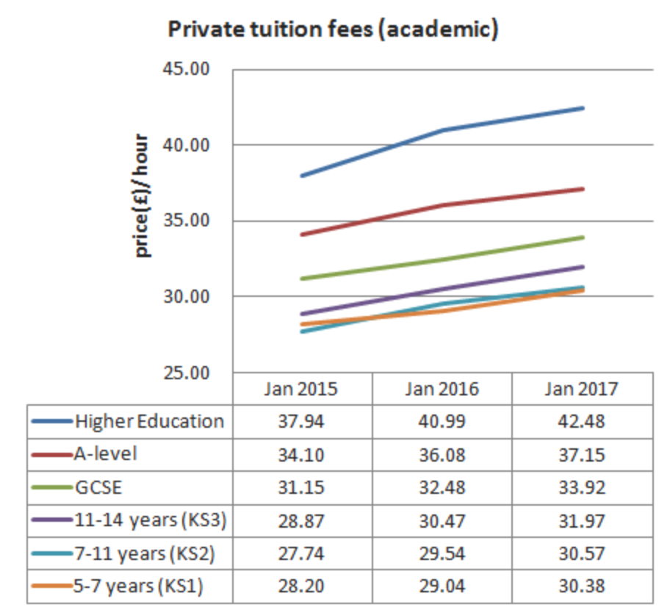

The Tutor Pages distributes yearly information on the normal hourly rates which private guides charge over the UK. The information is exact in light of the fact that it depends on the rates charged by more than 2000 free private tutors, and not on private agency data.

* In 2017, for academic tuitions for up to the age of 14, private tutors are charging on average between £30.40 and £32 every hour.
* GCSE educational cost is averaging around £33.90 every hour, and A-level educational cost is charged at by and large £37.20 every hour.
* For higher level studies like university, the charge increments to, on average, £42.50 every hour.

**Online Tuition & Independent Tutors**

The Tutor Pages have an indepth overview report into **online tuition** cost demonstrated that many tutors charged a similar rate when they were tutoring on the web. In any case, some reduced their rates somewhat. It shows in the study, around a quarter expressed that they charged 70%-100% of their face-to-face fee.

**Key Findings:**

* Around 80% of UK tutors use Skype to tutor online;
* The cost of online tuition is about the same as face-to-face, or slightly less;
* Payment is usually made by bank transfer, or through Paypal;
* Parents will often choose online tuition because of the convenience, the lack of local tutors, or because they’re living abroad;
* Online tutors report a number of advantages, such as flexibility in lesson scheduling and no travel costs;
* Some online tutors believe that students can learn better online compared to face-to-face;
* Online tuition is most popular for secondary school subjects or for adult learning.

**Independent tutors** advertise in the [Tutor Pages directory](https://www.thetutorpages.com/tutor-search), meaning that you can contact them free of charge. Using the company’s service meaning you’ll avoid the extra cost of agency commission or ‘finder’s fees’. Tutors have placed adverts the webiste site. So as well as it is free of charge, you don't even need to login: just use the each bar above. Unlike a tuition agency, The Tutor Pages does not get involved in payments. Each tutor displays their own rates, and will explain their terms of business when you contact them.

Private tutors’ fees can vary considerably, so these are the following factors which can influence fees:

• Experience

• Qualifications

• Track record

• Travel costs and travel time

• Online tuition vs face-to-face tuition

• Preparation required

• Cost of materials

• Subject level

• Initial assessment

• Discounts offered for block bookings

Comparison and Safeguarding - (Fahim Ahmed)

I will be speaking about my tutor website…

What they use in their websites to get there customers (students etc)

How they present this for e.g. (advertisement)

Why students would use this service?

Safeguarding mainly

prices

<https://www.mytutor.co.uk/how-it-works.html>

Mytutor website - there main heading is, Find your ideal tutor for one to one online lessons.

Some of My Tutors features -

* Face to face video

(where students chat to their tutor by live video, helping to build that important one- to one rapport)

* Also have a document upload

(resources placed here, past papers and pictures of diagrams etc)

* Collaborative tools

(an online interactive whiteboard can be used by both tutor and tutee)

There costs vary depending on which of their service you use - for e.g.

Take one-to-one tutorials from £18/hr  
  
Once you've found the right tutor, you can book sessions affordably and pay as you go. Payments are made easily and securely on the site. By learning online, you cut out travel costs and make savings of up to 40%.

This website is really focused on the aspect on the safety of the students. These are some of the policies which they follow that are stated on their website.

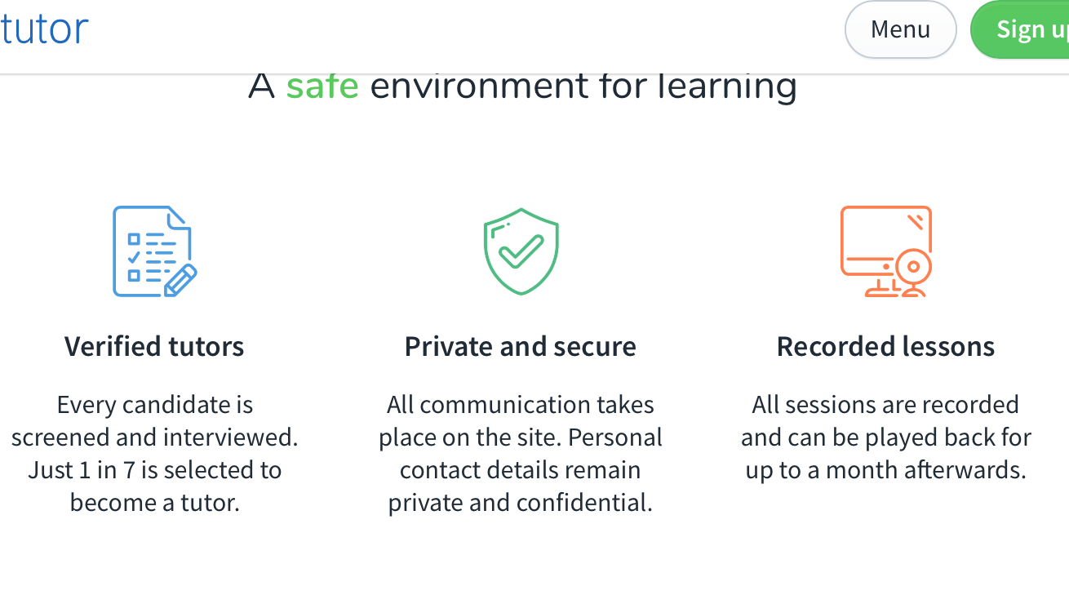

There tutors have to be verified, therefore they take the procedure of their students safety and concerns as priority. The communication which takes place online they will keep private and won't share the information around due to rules and regulations. And data protection acts. In addition to this all the sessions are recorded and also can be played back yourself after a month. This can be beneficial for both the tutor and tutee.

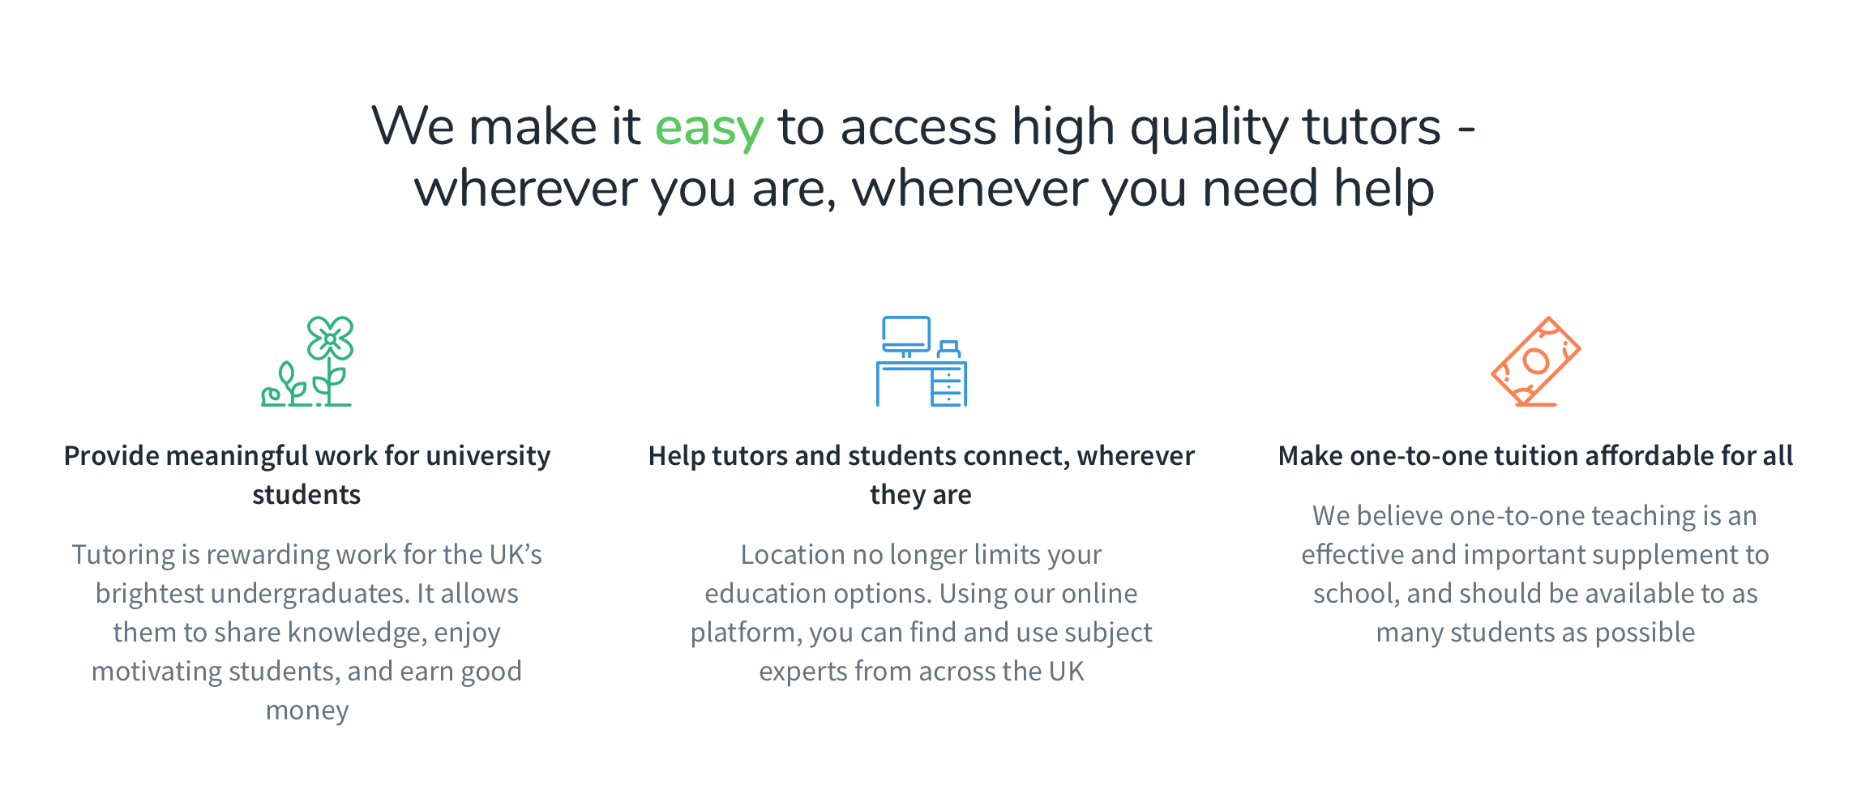

This above is what they believe.

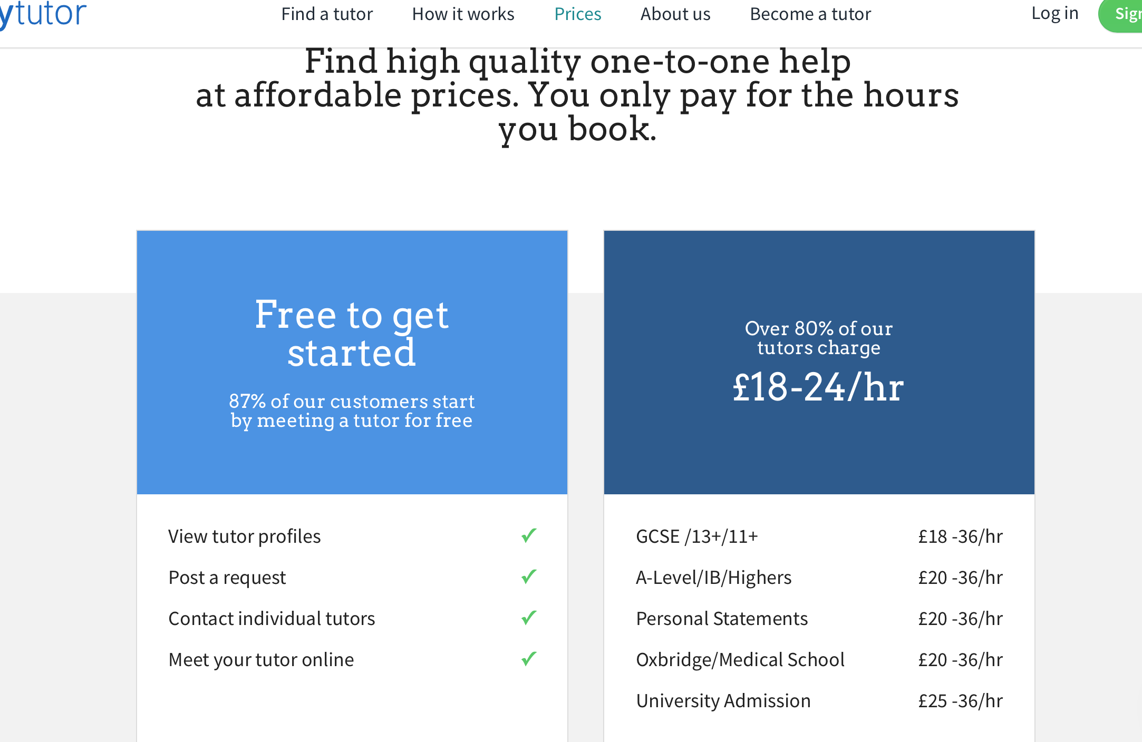

This is just how to get started in there website, if you want to join whether you're not sure if this is the correct or best tutor site. Well some tutors give a free trial first time you meet however some tutors may charge. As you can see the price range above it differs. It starts from as young as 11+ for gcses. I believe you can be as old as you want to use this service. No age restrictions.

Therefore Using for this service what does it get you?

* Well you get one - one tuition

(if you have time read this, <http://www.telegraph.co.uk/education/2017/10/10/private-tutoring-time-invested/>

Explains what parents want in a tutor, e.g. the build up of rapport between tutor and child)

This article also explains certain aspects which if you take away change the meaning of tutoring. For e.g.

Sharing a tutor between friends reduces the cost but also removes one of the main advantages of tutoring, namely one-to-one attention. The exception is foreign languages, where groups could help in conversation practice, provided pupils are at a similar level.

* You also get your recorded sessions

Therefore you can play this back at later stages, go through certain topics or the video more than once.

* Interactive learning environment

This is like a online tools environment. Interactive learning takes place such as, having quizzes or diagrams. Online board etc. This is getting much popular lately and a lot more students are using this than before.

* You also get written feedback

This is where students can get feedback of how they are progressing or what their good and bad flaws are. How can they improve? What can they improve on? When the tutors can give them feedback on how well they are progressing and also the students can ask questions.

HOWEVER I BELIEVE WHAT WOULD BE DIFFERENT WOULD BE IF ALSO THE STUDENT CAN GIVE FEEDBACK ON THE TUTOR. NOT LIKE A REVIEW HOWEVER A FEEDBACK WHERE THE TUTOR CAN TAKE ON BOARD WHAT THEY CAN IMPROVE ON.

Safeguarding

1.1 MyTutor (MTW) is committed to ensuring the highest possible standard of safeguarding. The personal safety and wellbeing of each student and tutor using MTW is paramount.

1.2 Our site was developed with the aim of ensuring that tutorials take place in a safe environment. This is reflected in a number of key built-in features and defined a set of policies and [procedures](https://www.mytutor.co.uk/safeguarding-procedures.html) for the students, parents/responsible adults and tutors who use this service

This shows that mytutor want their students to get the best learning experience in the best way and in a safe environment in safe hands. For this they have set rules and regulations to keep their students safe.

2.Legislative Framework/Related Policies

2.1 These policies and [procedures](https://www.mytutor.co.uk/safeguarding-procedures.html) aim to ensure that all persons using the MTW services can do so safely within child safeguarding standards and UK law.

These policies should be read in conjunction with the [MTW Terms and Conditions](https://www.mytutor.co.uk/terms.html) and the [procedures](https://www.mytutor.co.uk/safeguarding-procedures.html).

They have to follow the child safeguarding standards and the uk law.

<http://ec.europa.eu/justice/fundamental-rights/files/rights_child/standards_child_protection_kcsc_en.pdf>

This site above explains some of the standards which should be implemented when safeguarding a child. Explains the risks, what to do etc.

3. Aims

3.1 The aim of this policy is to safeguard all students and other persons using MTW system whilst they are within a tutorial session.

3.2 This policy document contains the responsibilities of all persons using MTW, including tutors, students, parents (responsible adults) and teachers.

3.3 It is important that all persons using or working on behalf of MTW are aware of this policy and have familiarised themselves with the detailed safeguarding [procedures](https://www.mytutor.co.uk/safeguarding-procedures.html).

3.4 This policy should be read and understood before engaging in any activity arranged through MTW and the responsibilities and [procedures](https://www.mytutor.co.uk/safeguarding-procedures.html) therein adhered to. Contravention of the policy document could lead to suspension and/or barring from the services.

They take their safeguarding seriously and as they said contravention to follow these procedures can lead to suspension or barring from the services….

Therefore everyone working here need to know the policies and follow it to become familiar with this.